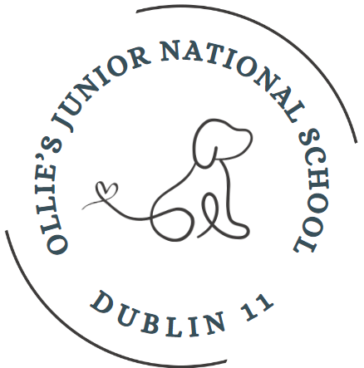
St. Oliver Plunkett’s JNS,
Finglas South
D11 XA46
Roll No. 19546C
p: 01 8344678 086-0117821
Email: info@ollies11.ie

PARENTAL COMPLAINTS POLICY
This document has been developed by Ollie’s to help members of our school community, including teachers, SNAs, parents and guardians if a complaint is made against a member of staff.

Rationale

The need for this policy arises from:-

Section 28, Education Act 1998 – procedures for processing complaints by parents prescribed for all schools under the Act.

Relationship to School Ethos

The school promotes positive home–school contacts and endeavors to enhance the self-esteem of everyone within the school community. The policy contributes towards those ideals.

Aims/Objectives

- To foster fruitful and trusting relationships between school and parents.
- To afford parents an opportunity to express opinions/grievances in an appropriate manner through the framework of a defined procedure.
- To appropriately resolve issues and problems arising in class or on yard.
- To protect the position and standing of the class teacher in the school.
- To minimize the opportunity for conflict through affording parents an opportunity to liaise with the class teacher and school management.

Please Note

This policy does not cover:

- Complaints that are being dealt with through legal channels.
- Matters of professional competence which come under the remit of the Department of Education and Skills
- Petty complaints which do not relate to the work of a particular teacher.

In-School Procedures

If a parent has a concern in relation to the social or academic progress of their child, to the performance of a teacher or regarding an incident on yard the following steps are to be followed. It is envisaged that engaging openly and positively in steps 1, 2 and 3 will resolve most issues:

- The parent/guardian may meet with the class teacher concerned informally in the morning or afternoon and, if necessary, arrange an appointment to discuss the issue with the teacher at a time that is agreed by both parties. The nature of the concern being raised should always be outlined prior to any meeting. Parents should be aware that a teacher has a class to teach during school hours. At this stage it is normal for a teacher to note the issue with the Principal.

- If the issue raised in step 1 concerns an incident on yard be aware that it will be necessary for the teacher to talk to the children involved and to the teacher who was on yard before trying to resolve the problem. This takes time. Also keep in mind that with young children it can be difficult to get an accurate account of exactly what happened. As a school though we will do our utmost to resolve any problems on yard and to make sure that yard is a happy place for all to play comfortably.

- If the issue is not resolved the class teacher informs the Principal in more detail of the nature of the complaint and every effort will be made to resolve it to the satisfaction of all involved. If the matter remains unresolved the parent/guardian may raise the matter with the Principal, generally by appointment.

- If the grievance persists, the parent/guardian may pursue the matter by lodging a complaint in writing with the Principal and/or the Chairperson of the BOM who will bring the nature of the written complaint to the notice of the teacher/Principal and seek to resolve the issue in a satisfactory manner.

- If this process fails, the Chairperson will supply the teacher with a copy of the written complaint and arrange a meeting with the teacher concerned and the Principal. This will happen within 10 school days of receipt of the written complaint.

- If the complaint remains unresolved the chairperson will report formally to the BOM within another 10 school days. If the BOM does not uphold the complaint, both parties will be informed immediately. If the BOM considers the complaint warrants further investigations, the teacher will be informed and supplied with any written evidence in support of the complaint.

- The teacher will be requested to supply a written statement to the B.O.M. and given an opportunity to make an oral presentation to the Board. The complainant will be offered a similar opportunity. The process should be completed within 10 days of the first meeting between Chairperson, Principal and Teacher.

- Within 10 school days, the decision of the BOM which is final and binding is delivered in writing to the Teacher and the complainant.

Success Criteria

- Swift and efficient resolution of grievances
- Parent/Teacher satisfaction
- Positive school community feedback
- Reviews of school policies as issues arise.

Review

This policy will be reviewed by the principal and BOM after a 3 year cycle.

Implementation

This policy was ratified by the Board of Management on 28th September 2023

It will be reviewed in June 2026, unless a review is needed before then.

Signed:
Principal: ____________________

Chairperson: ______________________

Date: __________________

Procedures to be followed when meeting your child’s teacher/principal:

St. Oliver Plunkett’s welcomes the contributions and support of parents but a teacher’s day is a busy one and the following guidelines help us as a school community to ensure that every day goes smoothly.

- If you wish to discuss your child’s progress in class, or an issue regarding your child which is related to the class you may, if it suits the teacher, discuss it informally with your child’s teacher in the morning or the evening.

- Remember though that the teacher has a class to care for, and to teach, and it is often the case that an appointment will need to be made, at a time that suits both of you, to meet to discuss the issue.

- Also it is better for everyone if the issue in question is stated clearly before any meeting so that your child’s teacher can have the correct information to hand.

- Where you are concerned with something that has happened on yard it is best to raise your concern with the class teacher who will pass it on to the principal. We will do our best to solve any problem on yard immediately. However we can only solve what we are told about so we need to be kept informed.

- Please do not take matters into your own hands if you have an issue that is related to school. While we appreciate that you are bound to be worried at times about your children it is very important that the right channels are followed to avoid conflict and upset.

- If you feel that you are not satisfied with the outcome of the meeting with the class teacher you are entitled to arrange a meeting with the principal. The principal is available by appointment but remember that if your concern is about something in the class you must have consulted with the class teacher prior to any meeting with the principal.

- If a parent/guardian is still not happy with the outcome of a meeting with the class teacher and the principal the matter may be raised with the BOM as per the schools Complaint Procedure Policy which is freely available on request to any parent.

Aggressive or threatening behaviour towards school staff will not be tolerated. Anyone engaging in aggressive or threatening behaviour will be asked to leave

